**Business Intelligence System Project**

**Fall 2025-2026**

**IT Digital Transformation**



**Karma Arrabi 20230067**

**Sara Kirresh 20230292**

**Noor Taha 20231115**

**Salma AbdelQader 20230094**

**Table of Contents**

1. Industry Overview and Importance 3

2. Business Intelligence Value and Competitive Advantage 4

3. Business Intelligence Technologies and Processes 5

1. Dashboards: 7

2. KPIS 8

3. Performance visualization and dashboard analysis 10

4. Recommended Data Warehouse Architecture 13

5. Data Source integration 16

References 18

**Table of Figures**

Figure 1: IT Digital Transformation Dashboard 7

Figure 2: Automation Rate KPI 8

Figure 3: Average Salary KPI 8

Figure 4: Total AI Investment KPI 8

Figure 5: AI Readiness KPI 9

Figure 6: Average Productivity of AI KPI 9

Figure 7:Number of Jobs Created by AI KPI 9

Figure 8: Scatter Chart Showing Automation Rate VS. Productivity Rate 10

Figure 9: Line Chart Demonstrating Job Displacement by AI Over Time 10

Figure 10: Box Plot Showing the Productivity Distribution by Country 11

Figure 11: Stacked Bar Chart Illustrating Net Job Impact Caused by AI 11

Figure 12: Azure Map demonstrating AI Investment by Country 11

Figure 13: Slicers that Enable Filtering 12

Figure 14: Data Warehouse Architecture (Sharda et al., 2018) 13

### **1. Industry Overview and Importance**

IT Digital Transformation is broadly defined as a comprehensive transformation process that heavily integrates the entire organization. It helps involve all functional departments and business units across the organization rather than being a single system. IT digital transformation has been built on a distinct strategic vision indicating a fundamental shift that has redefined how an organization likes to compete, utilize or deliver value. Such a vision has helped organizations change their long-term goals through the process of combining all advanced technologies into all areas within the organization. These technologies include cloud computing, data analytics, automation, and digital platforms business intelligence, which collectively support transformation and executional flexibility (LeanVlog, 2022). Through this transformation, the change and evolution an organization faces should change the way the business operates by how you deal with customers, how your data is managed and how you organize your production process for decision-making. As a result, IT digital transformation allows organizations to become more customer-focused, data-driven and highly competitive in an age where digital environments are increasing.

IT digital transformation is distinctly defined as an independent industry that deals with its own market structure, vendors, technologies, data and BI necessities. Market structure in IT digital transformation is promptly changing and growing due to the effect of several different organization sectors looking to streamline operations, improve digital infrastructure and maintain market competitiveness. Such markets include governments that fund digital solutions to enhance efficiency, customer experience and innovation (LeanVlog, 2022). As organizations progressively fund in cloud computing, analytics implementations, process automation, digital transformation has advanced into a distinct industry that has a significant role in the global economy.

Data plays a big role in the IT digital transformation, since it relies on large volumes of varied data. Data is generated in multiple ways such as ERP systems, cloud platforms, and OLTP. Data gained from such systems are usually high in volume which means there is a large amount of data, velocity where data is generated very quickly and continuously and variety shows that data comes in multiple forms such as structured, semi-structured and unstructured data. Due to these characteristics, traditional tools that collect data cannot handle the scale or speed of data so up-to-date systems are needed to store, process and analyze the data. Correctly controlling such data allows organizations to measure how successful digital transformation efforts are and monitor system performance (Kimball & Ross, 2013)*.*

Since IT digital transformation generates large amounts of data and needs constant monitoring and evaluation, hence it is difficult to operate effectively without Business Intelligence. Business Intelligence is required to integrate data that comes from different sources such as cloud systems and analytic tools into one place. In addition to real-time dashboards that are interactive and help managers check the organization’s performance as it occurs. Most importantly KPI’s, which are needed to monitor the performance of the organization and it is all compared to a target that has been set at the beginning and measures whether a transformation is successful or not. Accordingly, BI plays a very important role in increasing the advantage of IT digital transformation initiatives and maintaining competitive advantage.

### **2. Business Intelligence Value and Competitive Advantage**

The IT digital transformation industry depends heavily on data to operate and make decisions, where organizations regularly assess performance, investments and outcomes. Continuously monitoring such activities help organizations track how well their systems are performing, how much money has been spent and invested and what results have been achieved. The value of BI is clearly demonstrated when you state how decisions were made before BI and how much better decisions became with BI. Decision-making before BI had its own characteristics such as manual reporting which is collecting data manually from multiple sources and adding them into a single report. Intuition or feelings-based decisions since managers did not have the power of real-time data instead, they had to use their own personal experience for decision-making. Hence, such characteristics may drive many limitations such as delayed insights since data was manually reported, Inaccurate data since humans are manually reporting data, this increases the chance of having more errors and redundancy. In addition to the lack of real-time monitoring, organizations could not track KPIs and compare them to their target that they have set at the beginning of their plan such as the examples we have in our dashboard: Total AI Investment (B$) → scale of digital/AI spending, Average Automation Rate (%**)** → level of process automation, Average AI Readiness Score → preparedness for transformation and much more. Therefore, prior BI implementation decision-making was slow and large amounts of errors were detected which as a result limited the organization’s power to respond to IT digital transformation challenges. As a solution to all these challenges BI was discovered.

Decision-making after BI is no longer based on intuitions or any manual reporting; instead, now, it is easier going where we have real-time data, interactive visualization and insights provided through our BI dashboard that we have created for this project. Our interactive dashboard permitted decision making through; showing KPIs instantly, allowing comparison across countries, monitoring trends over time according to our dataset from (2015-2025), linking investments to outcomes and reinforcing interactive analysis. All of these actions helped the organization to act rapidly, allocate resources properly and monitor the success of IT digital transformation more. Overall, the implementation of BI shifts decision making from a reactive and fragmented process to a real-time data driven decision making process that supports strategic alignment and competitive advantages.

### **3. Business Intelligence Technologies and Processes**

**BI Technology Overview** refers to a group of techniques, procedures, and technologies used to convert data into useful information for making decisions (Turban et al., 2011). In this project we used BI to examine data on the adoption of AI, automation levels, employment rates, productivity performance, and investment trends across a number of years in various nations.

**BI as a technology** enables organizations to convert raw and processed data into valuable insights that support strategic, tactical, and operational decisions. It integrates a data storage system, analytical methods, and visualization tools to help decision makers understand patterns and trends. Based on this dataset, BI technology helps explain how automation and AI investments influence productivity levels and employment outcomes across countries and over time (Turban et al., 2011).

**Storage technologies:**

* **Databases:** Databases are utilized for storing structured information in an organized and reliable way. Based on this project, databases are capable of holding information at a country level concerning AI investment, automation levels, employment, and productivity metrics, making the data easy to manage and access for analysis.
* **Data warehouses:** A data warehouse is a centralized system designed to store large volumes of historical data that are optimized for analysis and reporting (Turban et al., 2011). In this project a data warehouse would integrate cleaned and standardized data related to AI adoption, automation, and employment across multiple years. This structure supports trend analysis, performance evaluation, and comparison between countries.

**BI processes:**

* **Data collection:** it includes collecting relevant data from different sources, which could be in industry reports, government statistics, and research reports. In this dataset it collects and prepares AI investment, degree of automation, employment rate, and productivity metrics to enable insightful analysis.
* **Data integration:** is a process where data from various sources can be combined into a single format. For this project, the process of data integration ensures that all the records of countries and years are presented with a consistent format of structured data measurements.
* **Data Analysis:** It revolves around trying to find patterns and relationships within the data. In this project descriptive statistics and regression analysis have been used to assess how investment in automation and AI have helped with productivity and employment outcomes (Turban et al., 2011).

**Performance visualization:**

#### **Dashboards:**

The dashboards facilitate an integrated and interactive visualization tool that combines important data and analytical outcomes for a concise overview. In this project, the dashboard is utilized for tracking adoption of AI, automation levels, employment trends, productivity, and investment patterns across different countries and years as shown in figure 1.

The dashboard integrates several visual components, which might be KPI cards, charts, and geographical maps. Users can examine data at a high-level view or detail view. There are interactive filters, which could be countries or years, used to dynamically explore the data and instantly update every visual element. Dashboards facilitate efficient examination or comparison or decision-making in the AI & automation industry.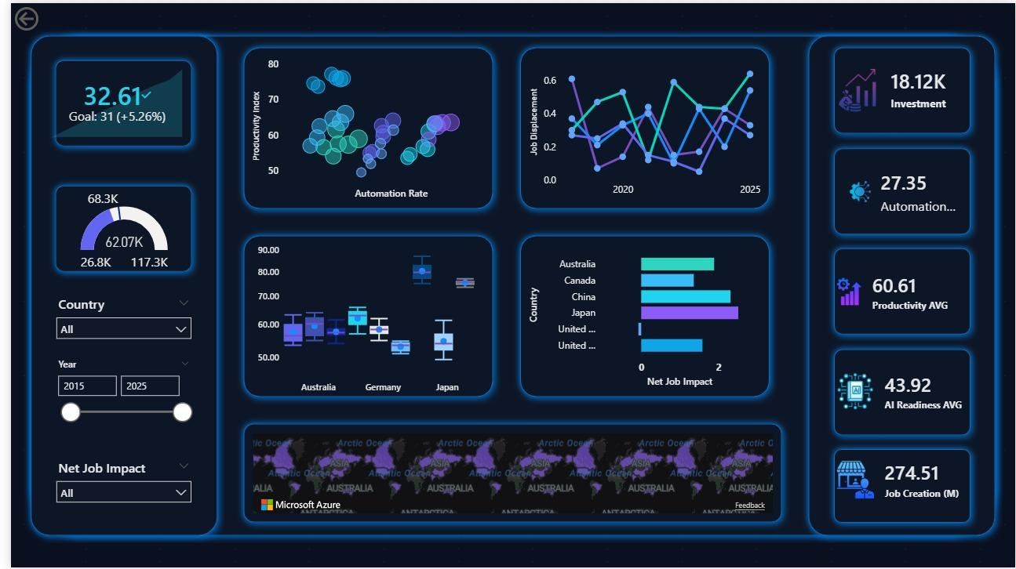

Figure 1: IT Digital Transformation Dashboard

#### **KPIS**

**Automation rate (actual vs target)**

As shown in figure 2, the KPI indicates that the automation rate has slightly outperformed its target, which tells a clear story of accelerated AI adoption across the organizations. Automation is going better than expected, which shows strong confidence in AI-driven processes and transformation of operations. However, this also means it has overshot its target, implying the rates of change are so rapid that systems are not fully prepared to handle them, such as workforce skills and regulatory frameworks. To an AI investor, this KPI is a signal of strong growth momentum but also a clear indication of investing in complementary capabilities to ensure that automation will drive value and sustainable outcomes rather than short-term gains in efficiency.

Figure 2: Automation Rate KPI

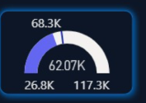**Salary KPIS (actual vs target)**

As shown in figure 3, the salary KPI is important, as it revealed that the average wages are below target, despite the increased levels of automation. This means that the economic benefits of the implementation of AI technology have not yet benefited the workers but are instead retained at the organizational or capital level. Although this is good for the immediate benefits of the organizations in terms of reduced costs, it might pose several concerns with regard to the future demands or the employees' morale or policy interventions. As the investor, the KPI would indicate that the current efficiency benefits may not be balanced.

Figure 3: Average Salary KPI

**Total AI investment KPI**

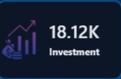Figure 4 shows the total AI investment KPI which indicates a massive amount of funds devoted to AI; this verifies that AI has become a new cornerstone in economic strategies instead of a trial technology. On one hand, this indicates a strong faith in AI’s long-term influences in the marketplace; on the other hand, it introduces a tough competitive environment in addition to high hopes for a strong return in these markets. As a criterion for AI investors, this indicates that their success would have no longer depended on involvement in AI markets but rather on their adept AI investments that would be superior in a crowded marketplace.

Figure 4: Total AI Investment KPI

**AI readiness KPI**

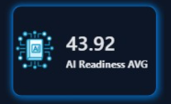Figure 5 shows the AI readiness KPI that emphasizes the important discrepancy between the desire for AI and the ability for AI. If the readiness level is not very high, this can indicate a certain level of ineffectiveness in the other aspects of AI readiness, from the underlying systems of the organization to the talent in AI, even with significant investment resources and the growth of the automated industry. Another investor-focused key performance indicator alerts the investor to the danger of relying solely on their investments and not necessarily improving the AI readiness.

Figure 5: AI Readiness KPI

**Productivity AVG KPI**

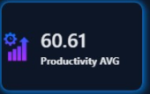As seen in figure 6, the productivity average of AI reveals a degree of productivity that is moderate among the countries, which means that although there's growth in the use of AI and automation, there is still potential that is yet to be realized in productivity. The KPI would point out an opportunity for value addition with regard to optimizing the use of AI and not spending more money since the degree of productivity is more dependent on the degree of implementation and not the amount.

Figure 6: Average Productivity of AI KPI

**Jobs created by AI KPI**

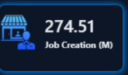Figure 7 represents the KPI for the number of jobs created which reveals how AI employment levels are affecting employment levels across different nations. A positive indicator indicates that AI is contributing positively to employment levels, which indicates that the use of AI is complementing human labor, hence ensuring that AI employment is socially sustainable, reducing any chances of resistance from society due to employment concerns. As an investor, this KPI is essential because it indicates that nations where employment levels are positively impacted will have stable policies.

Figure 7:Number of Jobs Created by AI KPI

#### **Performance visualization and dashboard analysis**

This section describes the BI dashboards’ visualization and how each graphic helps in the analysis of the dataset regarding automation, productivity, investment, and AI adoption across countries and years.

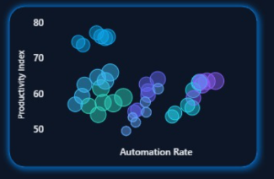**Scatter chart (automation rate vs productivity)**

As seen in figure 8, the graph shows the efficiency with which each country is realizing value from their AI investment. Although increased automation is believed to impact productivity, it is seen from this graph that increasing automation does not necessarily have a consistent impact on productivity. The bubbles that are larger indicate greater AI investment, but smaller bubbles mean less productivity, which may indicate they have yet to achieve efficiency. However, as far as AI investors are concerned, this clearly states that their focus should be on efficiency rather than just relying upon their expenditure.

Figure 8: Scatter Chart Showing Automation Rate VS. Productivity Rate

**Line chart (Job displacement over time)**

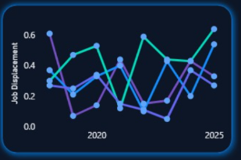Figure 9 is represented through a line chart, which shows the extent of job displacement by the AI at varying rates in different nations over time. Nations with extreme peaks face sudden changes in their workforce, leading to social unrest and political instability.

Nations with smooth ascents show a measured pace of adopting AI, giving time to adapt to new dynamics in terms of skills and job shifts. As an investor, it is quite evident from this graph that it is essential to focus on the speed of automation as a risk parameter since smooth transformations maintain stability in investments.

Figure 9: Line Chart Demonstrating Job Displacement by AI Over Time

**Box plot (productivity distribution by country)**

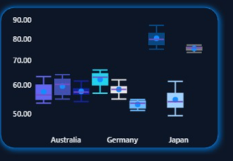As illustrated in figure 10, the box plot of productivity shows the consistency of AI-driven productivity performance across countries. Narrow distributions reflect stable productivity performance across years as an indication of strong governance, reliable infrastructures, and effective AI implementation. Wide distribution indicates volatility and poor execution, where the benefits from AI are inconsistent because AI is weakly integrated or because of institutional gaps. To investors, this chart is a signal that predictability is an asset; a stable productivity environment minimizes uncertainty and builds confidence in long-term returns.

Figure 10: Box Plot Showing the Productivity Distribution by Country

**Stacked bar chart (Net job impact)**

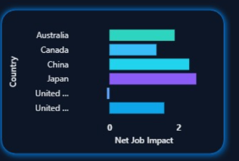Figure 11 shows a chart which illustrates the extent to which AI adoption is creating or displacing jobs over time, indicating the level of social sustainability within the respective countries. Countries that exhibit a positive net job impact over time indicate that AI is complementing human labor rather than replacing it in their economies, which in turn leads to greater societal acceptance and government support for continued AI adoption. Countries with a negative net job impact are more likely to face resistance in the form of regulatory intervention in the long run, which may discourage investments in these technologies. This chart is particularly important for AI investors to identify economies where their AI investment should support inclusive growth in these nations.

Figure 11: Stacked Bar Chart Illustrating Net Job Impact Caused by AI

**Azure Map (AI investment by country)**

As shown in figure 12, the following map of AI investment reveals the balance between concentration and opportunity. While the most highly saturated regions attract the most capital, they frequently return the least due to competition and market maturity Conversely, more moderately invested-in regions that are improving in readiness represent the emerging opportunities where early investors can capture policy incentives and benefits from market expansion. The following map invites investors to look beyond established hubs and identify underexplored regions with strong growth potential.

Figure 12: Azure Map demonstrating AI Investment by Country

**Slicers**

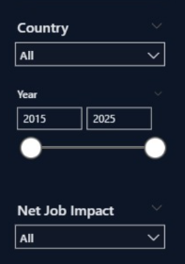Figure 13 shows, the slicers that make it possible for the dashboard to go from a report to a decision support system. Through data slicing, an investor is able to zero in on particular scenarios, picking out trends that would be missed when data is aggregated. Data can be sliced along country, year, or net job effect, making it possible for an investor to derive insights that, once again, emphasize the importance of context when making investment choices.

Figure 13: Slicers that Enable Filtering

### **Recommended Data Warehouse Architecture**

Figure 14: Data Warehouse Architecture (Sharda et al., 2018)

For the IT digital transformation industry, the recommended data warehouse architecture is the three-tier data warehouse architecture. A data warehouse environment is commonly described using three layers: a bottom tier that includes operational data sources and the back-end processes responsible for collecting and preparing data, a middle tier that represents the enterprise data warehouse where integrated data is stored and organized in OLAP servers that provide multidimensional data from warehouses, and a top tier that includes front-end BI tools used for reporting, analytics, and visualization and is treated as an application layer. Multitiered architecture serves large-scale information systems such as an IT digital transformation dataset (Sharda et al., 2018).

As shown in figure 14, the first tier consists of the operational data sources and the ETL (extract, transform, load) processes. The data sources are independent operational systems that store transactional data such as OLTP databases, point of sale systems (POS), legacy applications, and even ERP systems. Each organization will have a different selection of data sources depending on the business processes they perform. For the IT digital transformation industry, the primary data sources include enterprise resource planning (ERP) systems to enable integration between business functions to track finances such as AI investments and reskilling investments. As well as an HRM data source to track employment rate, average salary (USD), job creations, and job displacements. An IT service management (ITSM) data source is highly important to keep track of the automation rate vs manual human processes. Productivity tools data sources, such as Microsoft 365 Analytics, measure the productivity index and how these tools are affecting the efficiency of the business processes. Also, an external data source such as databases that relate to the economic situation of each country like employment rates and productivity measures to allow for benchmarking to occur. Many more data sources relating to financial planning and learning management systems can be added as well.

In addition to that, the first tier also consists of the ETL process, it is a main component because it integrates data from independent sources. It focuses on selecting the appropriate data and extracting it from the data sources such as the ERP systems, HRM systems, training systems as raw data and then transforms it into clean data that’s accurate in order to load it into the data warehouse. The transformation process includes consolidation, cleaning, scrubbing and cleansing the data to make sure it is in the correct format and ready for visualization. Some of the common errors in datasets include null values, duplications, inconsistencies in the formatting or mistakes in calculations such as the “net job impact” in the dataset selected. Before the loading phase, the data should be integrated, and in the loading phase the prepared data is stored in the data warehouse as structured tables, making them ready for analysis through dashboards, KPIs, and visualization tools (Sharda et al.,2018).

After the data is transferred into the warehouse, it is stored in a star schema which includes a central fact table that is surrounded by dimension tables that provide context and details. The data that is stored here will be used for OLAP processes and analysis since it allows for multidimensional data from data warehouses (Sharda et al.,2018) via the middle tier. The data is then transferred into specialized data marts. The selected data marts for the digital transformation industry based on the data could include a workforce data mart, financial and investment data mart, operational performance Data mart, and an automation data mart. After organizing the data in data marts, the OLAP processes that occur in the second tier begin to analyze the data from multiple information systems at the same time, representing a multi-dimensional cube. Some of the OLAP operations include (Pivot, Drill down, slice and dice and roll up). For this data, it is recommended to slice the data to compare the different years vs the AI readiness amount, or to roll up to analyze from a country or global level. Each operation intends for a different role to allow for maximum analysis of the cube from different points of views.

Finally, the last component of the data warehouse are the visualizations which are considered as tier three. The end user will be able to view the data as dashboards, scorecards and insights that higher management will use to improve decision making and manage weaknesses.

### **Data Source integration**

Because of the scattered nature of digital transformation data, data source integration is a must-have for Business Intelligence solutions in the IT Digital Transformation business. Unlike traditional companies, which rely on a single operational database, digital transformation initiatives collect data from several financial, human resource, operational, and external economic systems (IBM, n.d.). Integrating these many data sources is critical for producing reliable, consistent, and decision-ready insights.

To capture the full extent of digital transformation performance, this project will require numerous data sources. Financial and enterprise systems give statistics on AI investment and technology expenditure, indicating the level of digital commitment. Human resource management systems include employment rate, income levels, job creation, and job displacement metrics, allowing for analysis of workforce impact. Operational and IT service management systems generate statistics on automation rates and system utilization, which indicate the current level of AI technology deployment. External statistics, such as national productivity and economic indices, enable benchmarking and cross-country comparisons.

These sources are integrated using the ETL (Extract, Transform, and Load) procedure. Data is extracted from independent systems in raw form. The transformation step standardizes measuring units, corrects discrepancies, eliminates duplication, and assures data quality across countries and years (Sharda et al.,2018). This stage is crucial for reliably and consistently calculating key performance indicators (KPIs) such as automation rate vs target, AI readiness score, productivity averages, and net job effect. Finally, the cleaned and formatted data is transferred to a centralized data warehouse, where it is ready for OLAP operations and analytical processing.

Integrated data greatly improves analytical depth and dependability from a business intelligence standpoint. It makes it possible to examine connections between employment outcomes, productivity performance, automation adoption, and AI investment using a single analytical framework. Without integration, insights would stay dispersed, making it more difficult to determine whether investments in AI are resulting in increased productivity, operational efficiency, or long-term job outcomes (IBM, n.d.).

In terms of Business Intelligence, integrated data considerably improves analytical dependability and depth. It enables analysis of the links between AI investment, automation adoption, productivity performance, and employment outcomes using a single analytical approach. Without integration, insights would be dispersed, making it difficult to determine if AI investments result in operational efficiency, productivity growth, or long-term employment

Furthermore, data integration enables advanced analytics that extend beyond descriptive reporting. The BI system enables trend analysis, regression analysis, and scenario comparison across nations and time periods by combining multidimensional data into a single dataset (Kimball & Ross, 2013)*.* This feature elevates dashboards from static reports to decision-support tools that assist investors and regulators in identifying efficiency gaps, monitoring transformation risks, and assessing long-term digital sustainability.

To summarize, data source integration guarantees that Business Intelligence systems serve as a single source of truth for digital transformation analytics. It increases data accuracy, strengthens KPI validity, and provides complete, multidimensional insights to aid strategic decision-making in the IT digital transformation business.

### **References**

### IBM. (n.d.). What is data integration? IBM. [https://www.ibm.com/think/topics/data-integration](https://www.ibm.com/think/topics/data-integration?utm_source=chatgpt.com)

Kimball, R., & Ross, M. (2013). The data warehouse toolkit: The definitive guide to dimensional modeling (3rd ed.). John Wiley & Sons.

LeanVlog. (2022, March 31). What is digital transformation – A brief introduction with examples, process and statistics [Video]. YouTube.  [https://www.youtube.com/watch?v=GjdGqf_3oSs](https://www.youtube.com/watch?v=GjdGqf_3oSs&utm_source=chatgpt.com)

Microsoft. (n.d.). Extract, transform, and load (ETL). Microsoft Learn. [https://learn.microsoft.com/en-us/azure/architecture/data-guide/relational-data/etl](https://learn.microsoft.com/en-us/azure/architecture/data-guide/relational-data/etl?utm_source=chatgpt.com).

Sharda, R., Delen, D., & Turban, E. (2018). *Business intelligence, analytics, and data science: A managerial perspective* (4th ed.). Pearson.

Turban, E., Sharda, R., Delen, D., & Aronson, J. E. (2011). Decision support and business intelligence systems (9th ed.). Pearson Education.